**2019103573 CN LAB - 14 SACHIN RAGHUL T**

**CISCO PACKET TRACKER**

**NETWORK TOPOLOGIES - Mesh, Star, Ring, Bus**

**MESH :**

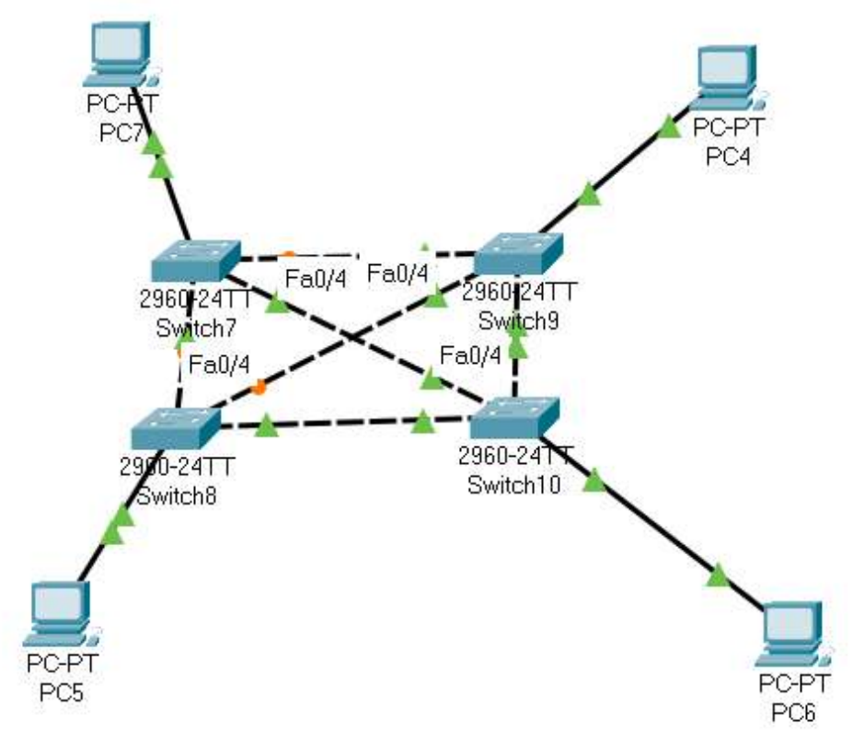

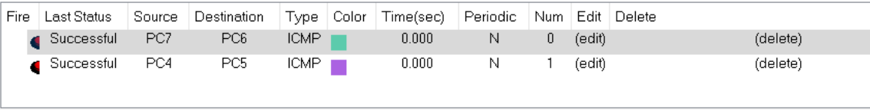

**STAR:**

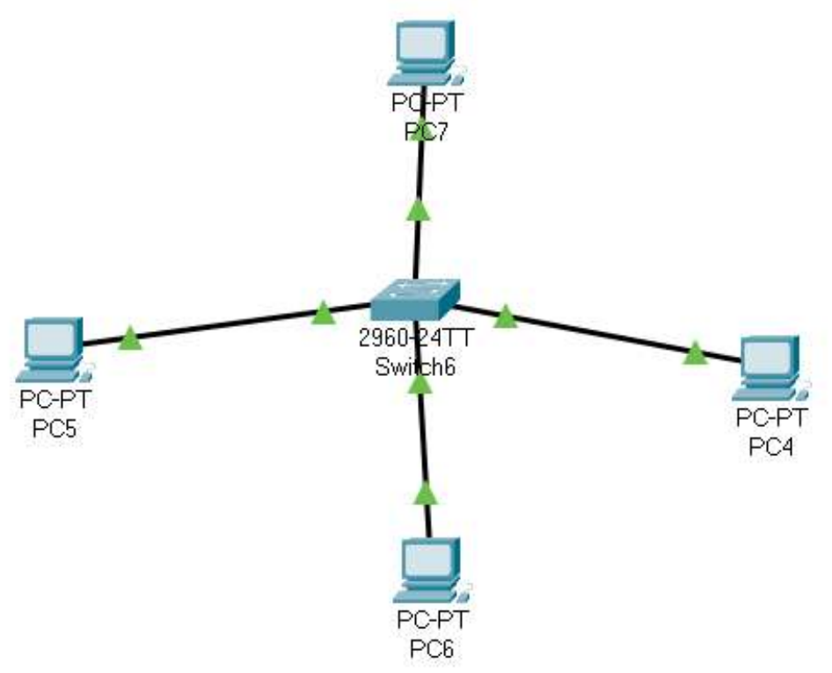

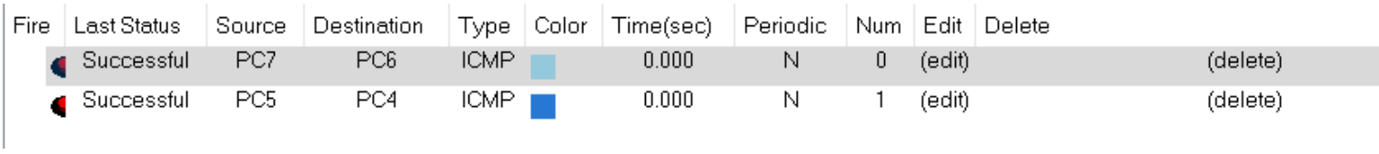

**RING :**

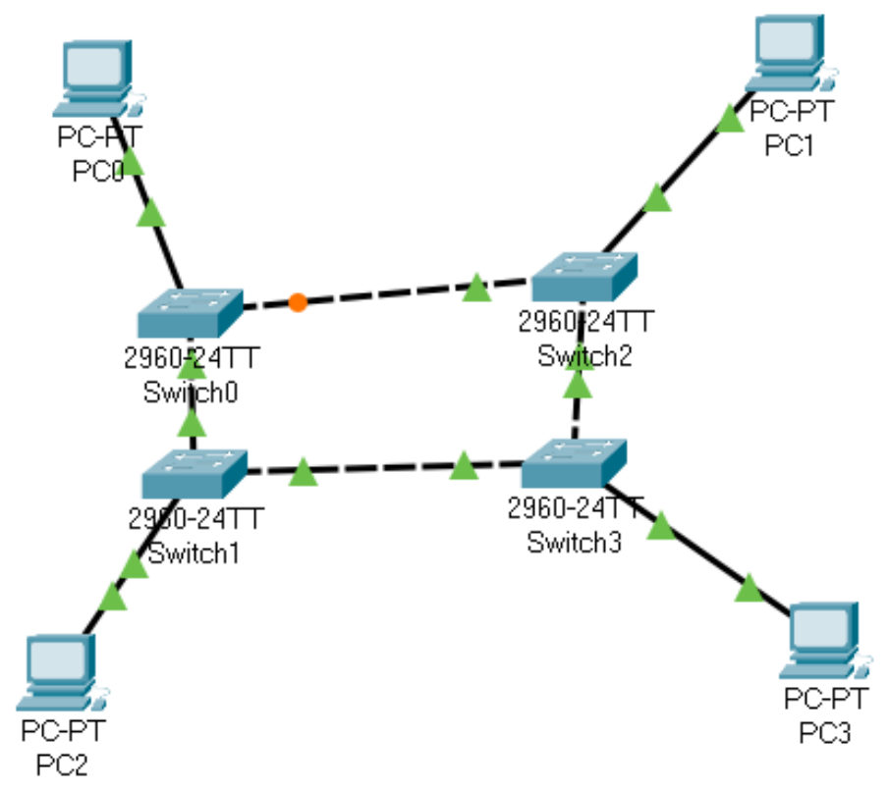



**BUS :**

